🎯 Magic Box Assignment – Problem Statement

Objective:

Create an interactive "Magic Box" using HTML and CSS. The box will change its appearance and behaviour based on user interactions like hovering and clicking.

📝 Requirements:

1️ HTML File (index.html)

You need to create a simple webpage containing:  
✅ A centered box (div) that will act as the "Magic Box."  
✅ A title (h1) above the box to display "Magic Box Assignment."  
✅ A footer (footer) with a small description or copyright text.

2️ CSS File (style.css)

You must use CSS to:  
✅ Style the box – It should be 200x200 pixels, with a background color of your choice.  
✅ Hover Effect – When the user hovers over the box:

The background color should change.

The box should slightly increase in size.  
✅ Click Effect – When the user clicks on the box:

The shape should change from a square to a circle.  
✅ Transition Effect – The hover and click changes should happen smoothly.

💡 Bonus (For Extra Marks)

🔹 Add a shadow effect when hovering.  
🔹 Use gradient colors instead of a solid background.  
🔹 Make the box responsive, so it looks good on both desktop and mobile.

Output: -  
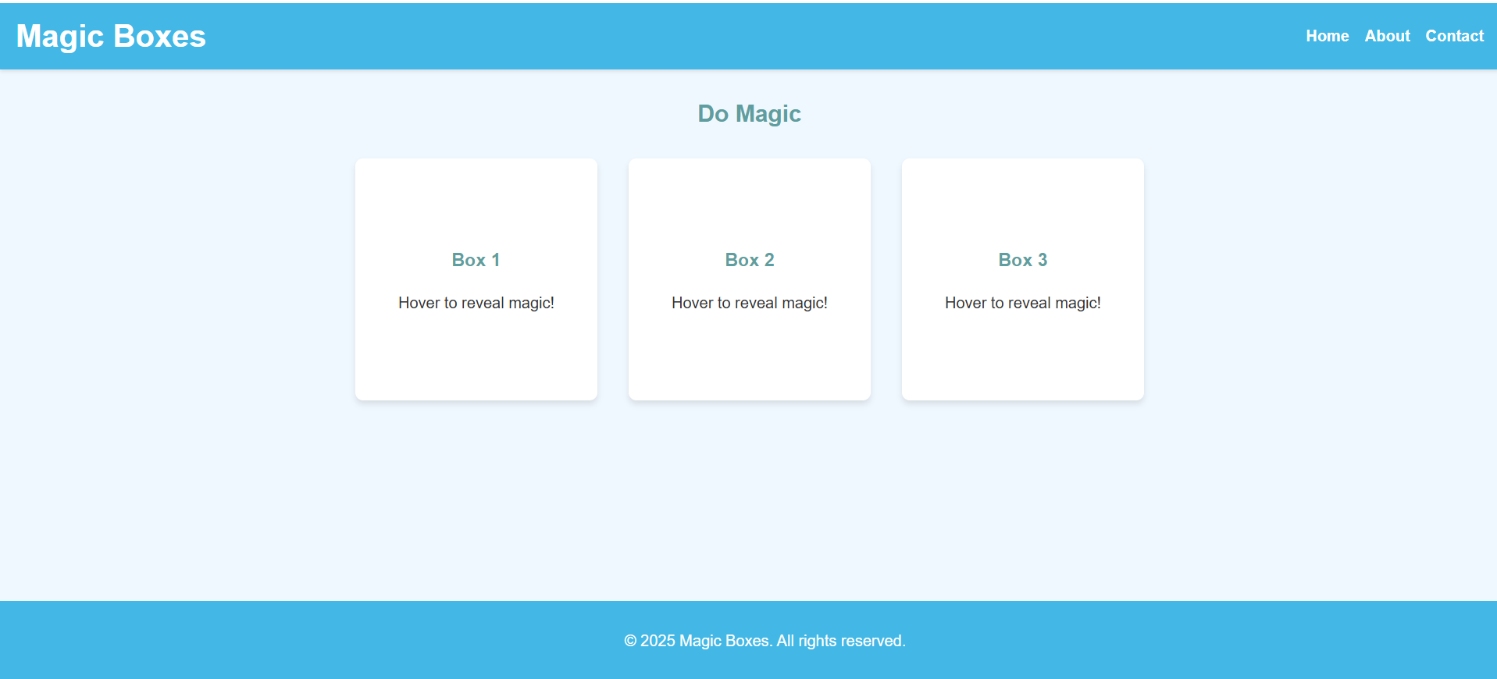

After hovering on Box, it will show image: -

